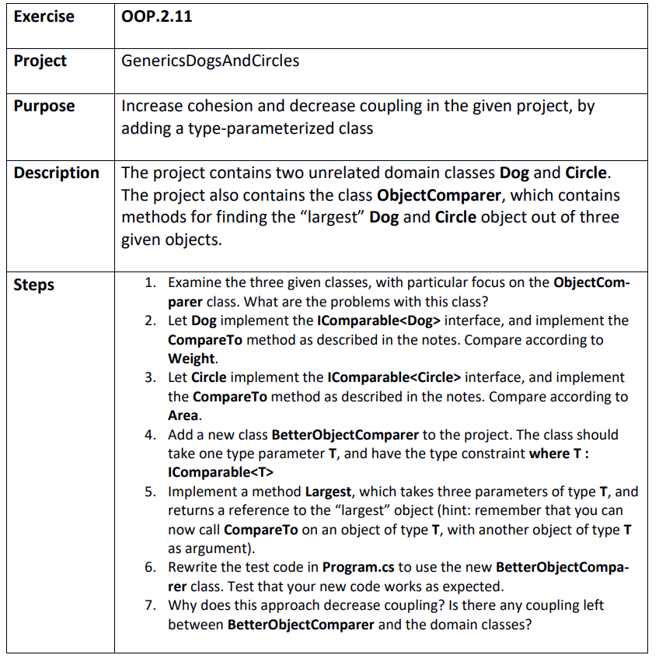

Step 1
C:\Git\OOProg25\Chap\OOProg02\MySolution\OOP.2.11 - GenericsDogsAndCircles\GenericsDogsAndCircles\GenericsDogsAndCircles.sln
The comparer takes exactly 3 objects which can be a problem
The same class is used for comparing different things. It has too much responsibility.

Step 2
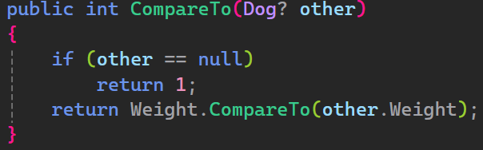

Step 3
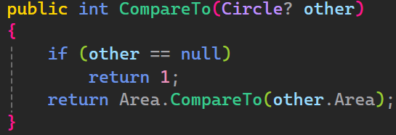

Step 4 & 5
